CCNA Lab Topology Arizona

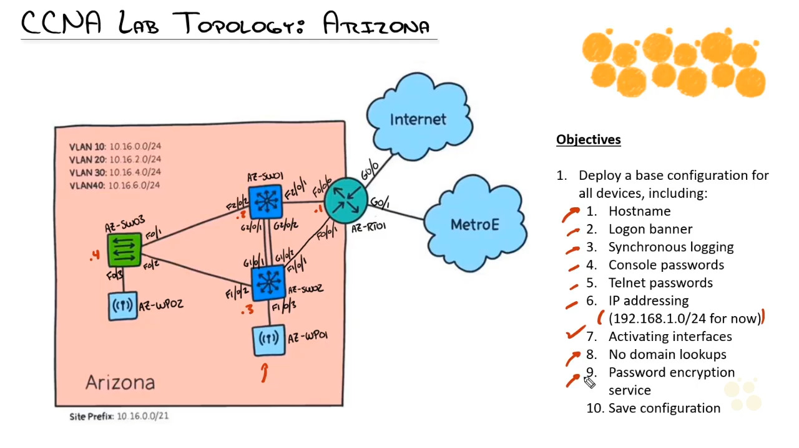

Objective

1. Deploy a base configuration for all devices including
   1. Hostname
      * Enable
      * Configure terminal
      * Hostname “name”
   2. Logon banner
      * Enable
      * Configure terminal
      * Banner motd line
   3. Synchronous logging
      * Enable
      * Configure terminal
      * Line console 0
      * Logging synchronous
        1. Keeps the status messages out of the way
   4. Console passwords
      * Enable
      * Configure terminal
      * Line console 0
      * Password “cisco”
      * Login (make it require the password)
   5. Telnet passwords
      * Enable
      * Configure terminal
      * Line vty 0 4
      * Login
      * Password “cisco”
   6. Protect privilege mode
      * enable
      * configure terminal
      * enable secret cisco
   7. Ip addressing
      * 192.168.1.0/24 for now
   8. Activating interfaces
      * Show ip interface brief
      * Enable
      * Configure terminal
      * Int g0/0 192.168.1.1 255.255.255.0
   9. No domain lookups
      * Enable
      * Configure terminal
      * No ip domain-lookup
   10. Password encryption service3
       * Enable
       * Configure terminal
       * Service password-encryption
   11. Save configuration
       * Enable
       * Wr
         1. OR YOU CAN WRITE THE ENTIRE COMMAND
       * Copy running-config startup-config

Notes:

When setting up the configuration for the VLAN, go into the interface and then set the ip address on the switch also. This way you can manage both the switch and the router.

When assigning the addresses for the router and switch to communicate you must assign the Vlan an Ip address. This way both sides can communicate with each other.